**Project Proposal On**

**Expenses Management System**



Prabin Ayadi

NCC ID: 00174621

Submission Date: 9th April 2019

Softwarica College of IT and E-commerce

Dillibazar, Kathmandu

Submitted To: Sudeep Lal Bajimaya

Module leader

Contents

**Chapter1. Introduction** 4

1.1 Project Introduction 4

1.2 Background of the project 4

1.3 Problem Statement 4

1.4 Description of the Project 5

1.4.1 Feature of the Project 5

1.5 Overview of the Project 6

**Chapter2. Scope of the Project** 7

2.1 Scope 7

2.2 Limitations 7

2.3 Aims 7

2.4 Objectives 8

2.5 Overview of the Scope 8

**Chapter3. Development Methodology** 9

3.1 Description of the Methodology 9

3.2 Design Pattern 10

3.3 System Architecture 12

**Chapter4. Project Planning** 14

4.1 Work Breakdown Structure (WBS) 14

4.2 Milestones 15

4.3 Gantt Chart 17

**Chapter5. Risk Management** 18

**Chapter6. Configuration Management** 20

**Chapter7. Conclusion** 22

**Chapter8. References** 23

# Table of Screenshots:

Screenshot 1: Waterfall Model 9

Screenshot 2: MVC design pattern 10

Screenshot 3: Three-tier Architecture 12

Screenshot 4: Work Breakdown Structure for Expenses Management System 14

Screenshot 5: Schedule of Expenses Management System 17

Screenshot 6: Gantt chart of Expenses Management System 17

Screenshot 7: Location for Git Push 20

Screenshot 8: Tree structure for Expenses Management System 21

# **Chapter1. Introduction**

## 1.1 Project Introduction

Expenses Management System is the name of my project. It will utilized for business purposes or a person to review their costs or expenses. This project enable clients to enter their salary and their expenses according to their needs. The main purpose of this project is to enable the spending thoughts of client’s expenses. It helps to recognize and analyze the overall expenses of clients and it will provides opportunities in case of cost saving and control the flow of excessive spending expenses.

## 1.2 Background of the project

People intended to live their life in smart way in present technological era. In Expenses Management System, clients enable to register and then login accordingly. Here clients can add their salary and their day-by-day expenses to maintain or control the flow of daily excessive expenses this will automatically help in saving purposes. This project will help to manage cash flow. In order to finish this project, time should managed properly according to the project needs.

## 1.3 Problem Statement

According to my view there are many problems arises without Expenses Management System. The main problem is that the clients would not noticed about excessive flow of expenses or costs.

Problem statement refers to the solution of the problem. This project will focused on individual or association who need to monitor their salary and their expenses. This project inform the clients that where the money goes or the flow of expenses. With the help of this project, we maintain the constant between day-by-day expenses.

## 1.4 Description of the Project

Description of the project include following requirements:

**Programming Language: Java**

**Tool: Android Studio**

**Platform: Android**

**Pattern: MVC (Model, View and Controller)**

**Database: SQL Lite**

To complete my project i.e. Expenses Management System I have used various tools like java (Programming Language), Android (Platform), MVC (Pattern), SQL Lite (Database). After the implementation of this project user can get clear about their expenses and their spending. To manage and control the spending of user this application is beneficial.

## 

## 1.4.1 Feature of the Project

Features of the Expenses Management System include following things:

* **Register**
* For register user using their Email Address, Username and Password.
* New information regarding clients will sent to Email.
* **Login**
* For login purpose, user will using their Username and Password.
* **User will edit their profile**
* Profile of user include Username, Password, Email and many other things that related to user profile.
* User can edit their salary and expenses according to their needs.
* **User will add their income**
* For calculation of salary and expenses user will add their income.
* **User will edit their income**
* If there is increase or decrease in salary user will edit their income according to their needs.
* **User will add their expenses**
* **User will view expenses**
* This feature help user to view the list of expenses.
* Provide information about where the money is going.
* **Report of the expenses**
* User will get report of the expenses by calculating all expenses.
* **Logout**

## 

## 1.5 Overview of the Project

Expenses management system will used for business purposes or a person to record expenses of user. It helps to record how user spend money and their spending habits. Monitor costs all year to augment reasoning’s, lower assessable pay and spare your organization cash.

Here I have used different things to complete this project. Some of them are Java (programming language), Android Studio (tool), Android (platform), MVC (pattern), and SQL Lite (database).

The main theme of this project is to user make better money spend decisions with concur expense.

# **Chapter2. Scope of the Project**

## 2.1 Scope

Expenses Management System intended to support individual or business spending plan, track and potentially control your costs. It helps in tracing both user income and expenses. The Expenses Management System gives a coordinated arrangement to cash flow and expenses of user. It gives the capacity to gather your income into classifications and gives you a chance to set a financial plan and track costs in the classification.

## 2.2 Limitations

Individual probably will not know or recollect where they spent their pay consequently the following of the cost will be problematic. Pay of individual probably will not be customary thus, their computation may not be right. The user spending may be more than that of their income. This application will not run on IOS because this application is only for android platform.

## 2.3 Aims

* The main aim of this project is to develop application where a user can add, update and track income and expenses and to control the excessive money spending of user.
* To produce efficient, secure spending amount and to deliver cost reports of users.

## 2.4 Objectives

* To perform user based design.
* To develop user-friendly application.
* To manage time according to the user needs.
* To get better software with less bugs, the developed application should tested properly.
* To design different types of diagrams like use-case diagram, activity diagram, sequence diagram etc.
* To illustrate the flow of application with the help of diagrams.
* To perform this project as both individual and business purposes.
* To analyze the views of users regarding this project.
* For further support all the system development, development methodology, diagrams should documented properly.

## 2.5 Overview of the Scope

Overview of the scope include limitations, aims and objectives of the Expenses Management System. Limitation of the project describes that the user expenses might not managed properly because individual could not know where they spend their income and for what purposes and the spending of user could more than that of income. The main limitation of this project that it is only for android user not for IOS user. In this way, aim of this project is to calculate expenses report by calculating spending money. Finally, objectives describes how to get better software and the documentation of design pattern, development methodology used, performance of the Expenses Management System for further support.

# **Chapter3. Development Methodology**

## 3.1 Description of the Methodology

**Waterfall Model**

The waterfall model was first process model and it is very simple to understand and use. In a Waterfall model, each phase must completed before the next phase can begin and there is no overlapping on the phase. It is the earliest SDLC approach that used for software development. (Tussen de Vaarten, 2013-2018)

Phases of Waterfall model includes following points:

* Requirements analysis
* Design
* Implementation
* Verification
* Maintenance

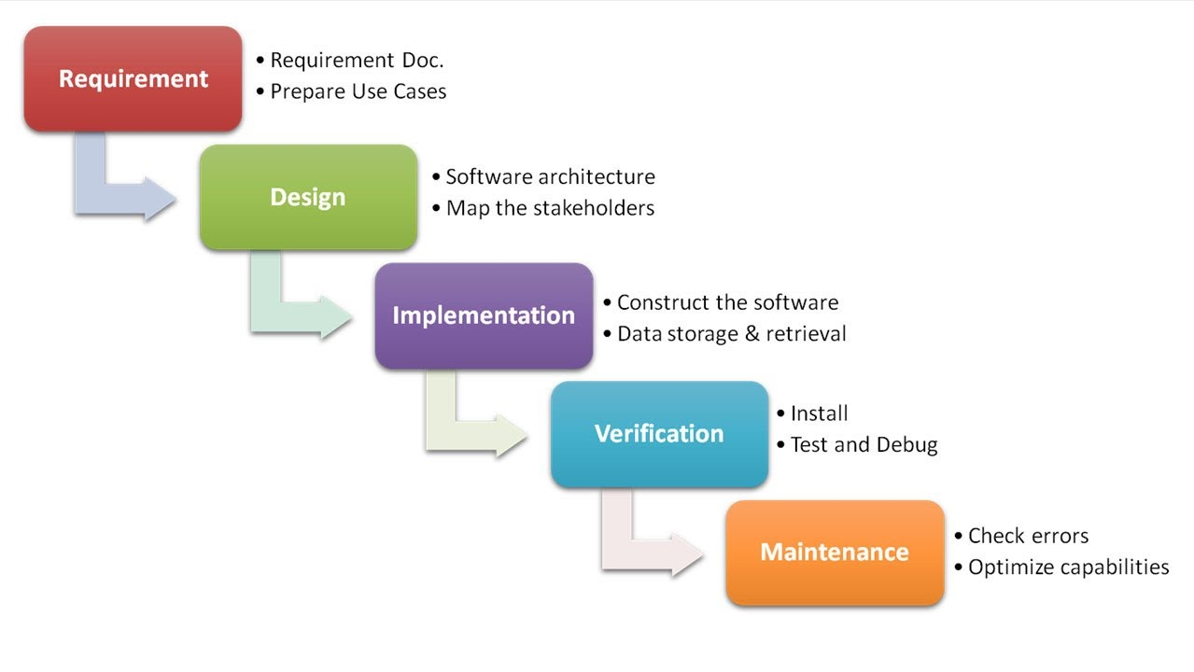

Screenshot 1: Waterfall Model

**I have chosen Waterfall Methodology due to following reasons:**

* This methodology is easy to understand and use.
* This methodology is mainly for small project.
* Phases overlapping does not occur.

**Advantage of using Waterfall Model:**

* Phases are proceed and completed one at a time. Therefore, that phase do not overlap.
* Clear estimation of cost according to the requirements.
* In this model, process of testing is more efficient and simpler.

**Disadvantage of using Waterfall Model:**

* Does not suitable for randomly change requirements.
* Going back to a phase is more difficult and costly efficient.
* Testing time comes very later. This is against the rule of software development.

## 3.2 Design Pattern

I will used **Model View Controller (MVC)** design pattern.

**Model:** Within the pattern, the model is the main components and the main purpose of the model is to manage the data, logics and rules of the application.

**View:** Output representation of the data in the form of a screen or user interface (UX).

**Controller:** Both model and view updates by controller. It control the data flow into model and updates the view if data changes. (Gootooru, 2019)

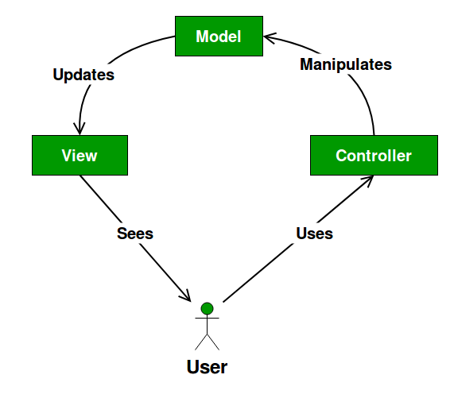

Screenshot 2: MVC design pattern

**I have used MVC design pattern due to following reasons:**

* MVC design pattern helps for developing user interface that helps to divide an application into three interconnected parts.
* This helps for display and data separate purposes by allowing changes without affecting the other.
* This design pattern provides efficient code reuse and parallel development.

**Advantages of using MVC design pattern:**

* Rapid and parallel development process i.e. faster development process.
* Ability to create multiple views for a model.
* Supports TDD (Test Driven Development).
* The entire model does not affected by modification because both model part and view part are different.

**Disadvantages of using MVC design pattern:**

* Complexity will increase.
* Multiple technologies knowledge is required.
* Multiple number of programmers needed.
* In view, there is inefficiency of data access.

## 

## 3.3 System Architecture

**Three Tier Architecture**

The three-tier architecture consists of three tier. They are:

* Presentation Tier
* Application Tier
* Data Tier

Presentation Tier:

In the three-tier system, presentation tier represents the front-end layer and consists of the user interface. This tier build on web based technologies or other popular web development frameworks and communicates with others layers through API calls.

Application Tier:

The application tier consists functional business logic and it has often written in java and other programming language.

Data Tier:

The data tier consists database, data storage system and data access layer. Data accessed with the help of application layer via API calls. Examples of data storage system includes MYSQL, Oracle, and SQL Lite etc.

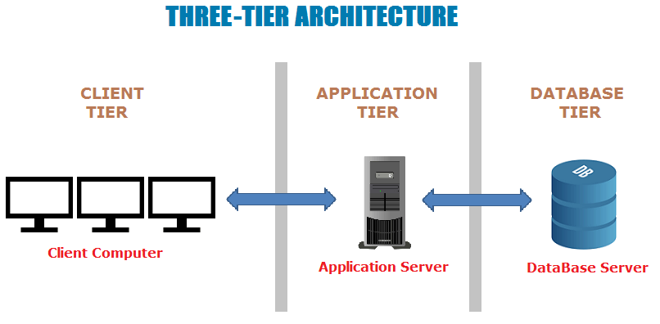

Screenshot 3: Three-tier Architecture

**I have used Three-Tier Architecture due to following reasons:**

* Development of process data, data access, data storage, user interface and computer data storage occurred here.
* It helps to work on separate platform and maintained as independent module.
* Better, re-use.
* Provide security i.e. client is not direct access to database.

**Advantages of using Three-Tier Architecture:**

* The third tier provides database management functionality.
* Without using any proprietary database management, data and file services can optimized.
* While hiding the complexity of distributed processing the performance, flexibility, maintainability, reusability and scalability of three-tier architecture is better than that of two-tier architecture.
* Improve data integrity and performance of application is better.

**Disadvantage of using Three-Tier Architecture:**

* Increase in complexity and effort.
* High installation cost

# **Chapter4. Project Planning**

## 4.1 Work Breakdown Structure (WBS)

To remove complexity and for manageable purpose a project is breakdown into smaller components called Work Breakdown Structure (WBS). It provides a hierarchical and incremental decomposition of a project into phases, deliverables and work packages. It breakdown the entire project into meaningful components. The Work Breakdown Structure for Expenses Management System are as given below:

* Project Management
* Analysis
* Design
* Implementation
* 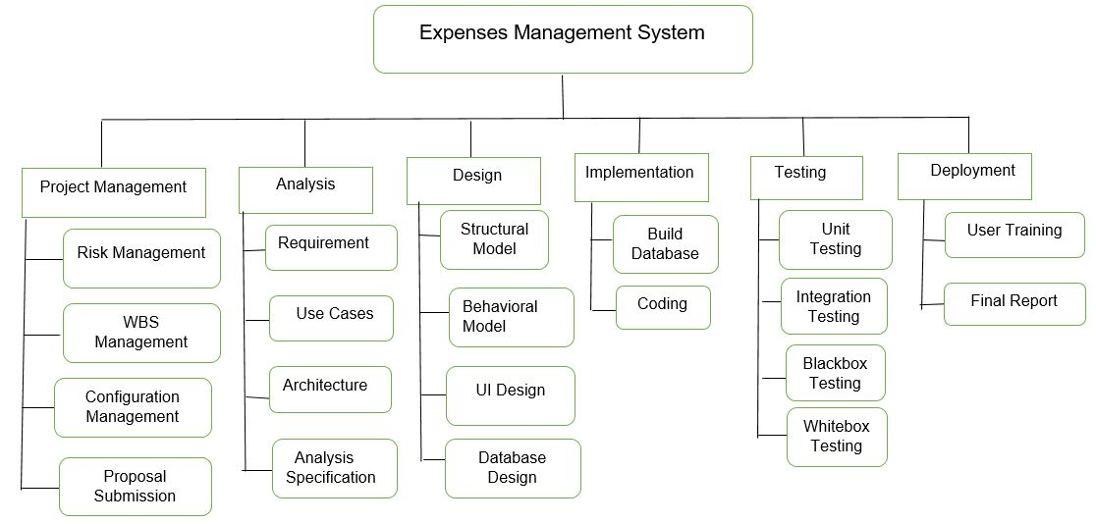Deployment

Screenshot 4: Work Breakdown Structure for Expenses Management System

## 4.2 Milestones

**Milestones Table:**

|  |  |  |  |  |
| --- | --- | --- | --- | --- |
| **S.N** | **Milestones** | **Start Date** | **End Date** | **Total Days (110)** |
| 1. | **Project Management**  Risk Management  WBS  Configuration Management  Proposal Submission | **03/25/2019**  03/25/2019  03/29/2019  04/02/2019  04/05/2019 | **04/07/2019**  03/28/2019  04/01/2019  04/04/2019  04/07/2019 | **14**  4  4  3  3 |
| 2 | **Analysis**  Requirement analysis  Use Case  Architecture  Analysis specification | **04/08/2019**  04/08/2019  04/16/2019  04/23/2019  05/02/2019 | **05/06/2019**  04/15/2019  04/22/2019  05/01/2019  05/06/2019 | **29**  8  7  9  5 |
| 3 | **Design**  Structural Diagram  Behavioral Diagram  UI Design  Database Design (ER, Data Dictionary) | **05/07/2019**  05/07/2019  05/12/2019  05/19/2019  05/26/2019 | **06/01/2019**  05/11/2019  05/18/2019  05/25/2019  06/01/2019 | **26**  5  7  7  7 |
| 4 | **Implementation**  Building Database  Coding | **06/02/2019**  06/02/2019  06/07/2019 | **06/21/2019**  06/06/2019  06/21/2019 | **20**  5  15 |
| 5 | **Testing**  Unit Testing  Integration Testing  Blackbox Testing  Whitebox Testing | **06/22/2019**  06/22/2019  06/26/2019  06/30/2019  07/04/2019 | **07/06/2019**  06/25/2019  07/29/2019  07/03/2019  07/06/2019 | **15**  4  4  4  3 |
| 6 | **Deployment**  User Training  Final Report | **07/07/2019**  07/07/2019  07/10/2019 | **07/12/2019**  07/09/2019  07/12/2019 | **6**  3  3 |

* To complete my project I have evaluated total 110 days. I have a short period to complete this project .So to build a project there is a combination of different phases. Each phases or milestones have their own sub-phases and own duration period. Project
* Management phase involves other sub-phases i.e. Risk Management, WBS, Configuration Management and Proposal Submission. I have evaluated 4 days for risk management because to minimize the potential problems and negative impacts on project. I have evaluated 4 days for WBS to breakdown a complete project into smaller components. I have evaluated 3 days for configuration management to managing, protecting and controlling the project product. I have evaluated 3 days for proposal submission in which I allocated 2 days for structuring and formatting the documentation and last remaining day I submitted my project proposal to the module leader.
* Analysis Phase involves other sub-phases i.e. Requirement analysis, Use Cases, Architecture and analysis specification. I have evaluated 8 days for requirement analysis to determine the actual need of user and requirements associated to complete this project. I have evaluated 7 days for use cases in which systematic description how the system works and how the system used by the user. I have evaluated 9 days for architecture to build regulations and sustainability standards of project. I have evaluated 5 days for analysis specification to identification and documentation of the real requirements.
* Design phase involves sub-phases i.e. structural diagram, behavioral diagram, UI design and database design. I have evaluated 6 days for structural diagram to demonstrate different structure and application. I have evaluated 7 days for behavioral diagram to construct, visualize, the system. I have evaluated 7 days for UI design for color tools, styles, and layouts. I have evaluated 7 days for database design to organize the data according to the database model.
* Implementation phase involves other sub-phases i.e. building database and coding. I have evaluated 5 days for building database to build the data management of project. In this way, I have evaluated 15 days for coding to develop an application.
* Testing phase involves sub-phases i.e. unit testing, integration testing, Blackbox testing and Whitebox testing. For unit testing I have evaluated 4 days to validate the units of software. For integration testing, I have evaluated 4 days to test the software in a group. For Blackbox testing I have evaluated 4 days to test structure, design of the software. At last, I have evaluated 3 days for white box testing to test the working pattern of software.
* Deployment phase represents the last phase of this project and involves sub-phases i.e. User training and final report. To train the user I have evaluated total 3 days and for final documentation of project, I have evaluated 3 days.

## 4.3 Gantt Chart

The schedule and the gantt chart of project are as given below:

Schedule:

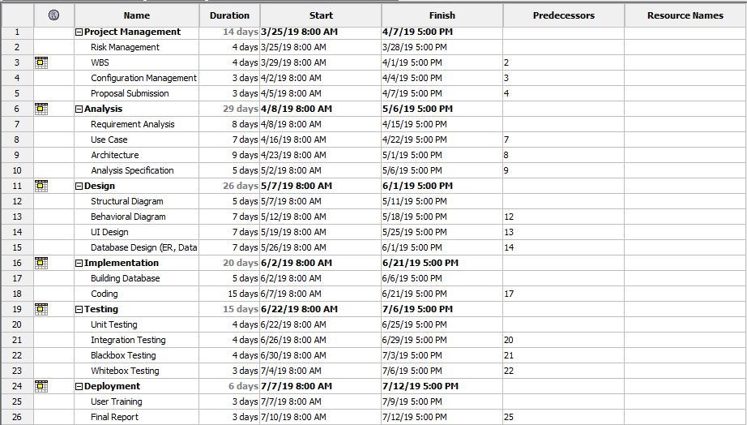

Screenshot 5: Schedule of Expenses Management System

Gantt chart:

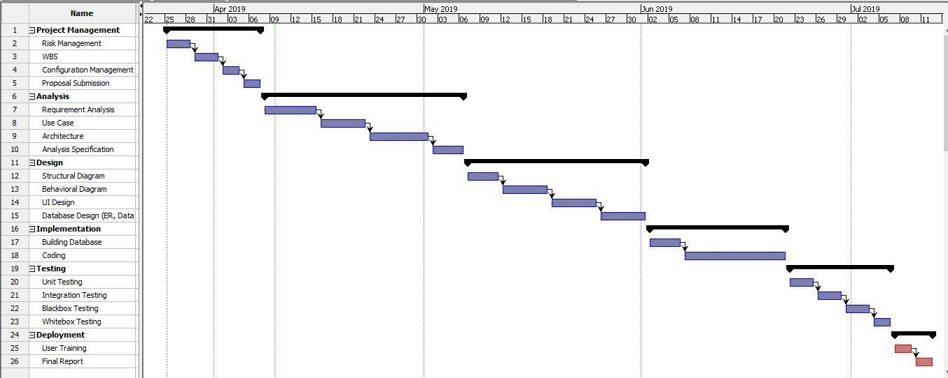

Screenshot 6: Gantt chart of Expenses Management System

# **Chapter5. Risk Management**

Risk management is the technique of identifying, assessing and controlling threats to a business using insurance, safety measures etc. The main purpose of risk management is to control or minimize the flow of unexpected risk, extra time and money. To get impact of risk on project we have mathematical calculation i.e.

Impact = Likelihood * Consequences

Likelihood values of risk are as given below:

|  |  |
| --- | --- |
| **Likelihood** | **Value** |
| Low | 1 |
| Medium | 2 |
| High | 3 |

Consequences values of risk are as given below:

|  |  |
| --- | --- |
| **Consequences** | **Value** |
| Very Low | 1 |
| Low | 2 |
| Medium | 3 |
| High | 4 |
| Very High | 5 |

## 

**Risk Table:**

|  |  |  |  |  |  |
| --- | --- | --- | --- | --- | --- |
| **S.N** | **Risks** | **Likelihood** | **Consequences** | **Impact** | **Solution** |
| 1 | Lack of resources | 2 | 3 | 6 | Before to develop application all the resources needed for project should provide. |
| 2 | Operating System failure | 2 | 4 | 8 | Do not overuse computer and provide file backup system. |
| 3 | Problem in flow of electricity | 1 | 5 | 5 | Uninterrupted power supply (UPS) must provide. |
| 4 | Lack of knowledge in users | 3 | 3 | 9 | Provide training to the users before implementation. |
| 5 | Virus, Threats | 2 | 4 | 8 | Regular scheduled scans with the use of installed anti-virus software. |
| 6 | Natural Disaster like Earthquake, flood etc | 1 | 5 | 5 | Implementation of cloud back up system. |
| 7 | Hard drive failure | 1 | 4 | 4 | To prevent from failure reduce data load and provide back-up system. |
| 8 | Lack of physical memory | 2 | 3 | 6 | Sufficient RAM and good processor. |

# **Chapter6. Configuration Management**

Configuration Management is the process for administrative activities concerned with the creation, maintenance, control change and quality control of the project. It helps to build the effectiveness, execution and dependability of the project. To effectively accessible from everywhere, files managed in sorted out structure.

The Username, GitHub Profile and Repository of my GitHub account is:

**Username: PrawinAyadi**

**GitHub Profile:** <https://github.com/PrawinAyadi>

The repository link of my GitHub account: <https://github.com/PrawinAyadi/EMS>

Below information shows the directory structure of project:

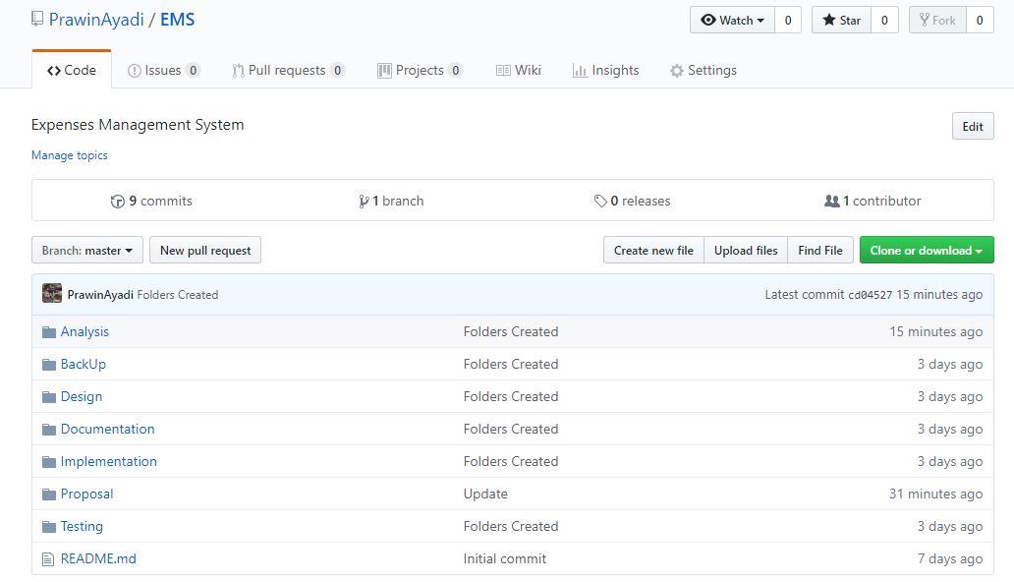

Screenshot 7: Location for Git Push

In GitHub account, I have created a total seven folder i.e. Analysis, Design, Implementation, Testing, Documentation, Proposal and Backup. The analysis, design, implementation, testing portion of the project uploaded in respective folder. Proposal of the complete project uploaded in proposal folder and documentation of the project i.e. final report uploaded in documentation folder. All the files associated with project comes under backup folder. This also helps in future use also if the file has deleted.

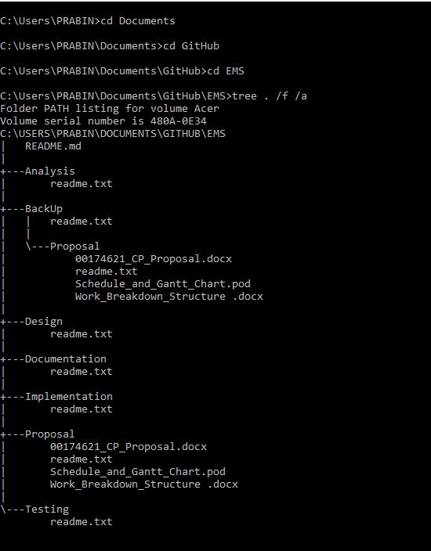

Screenshot 8: Tree structure for Expenses Management System

# **Chapter7. Conclusion**

The main purpose of my project is to inspire the clients to lessen their spending. User can easily manage their expenses with the use of this application. To control or maintain the flow of expenses user can add their salary and daily expenses and it helps to manage the cash flow. This application is a valuable resource for cost saving, auditing and financial analysis. Error caused by a paper process and delay in reports reduced with the use of this application.

# **Chapter8. References**

Bennett, C., 2019. *The Economics Times.* [Online]   
Available at: https://economictimes.indiatimes.com/

Gootooru, N., 2019. *java2novice.* [Online]   
Available at: http://www.java2novice.com/java_interview_questions/mvc-pattern/

Tussen de Vaarten, A., 2013-2018. *TOOLSQA.COM.* [Online]   
Available at: https://www.toolsqa.com/software-testing/waterfall-model/